
Products | Dixon
Terminal Product

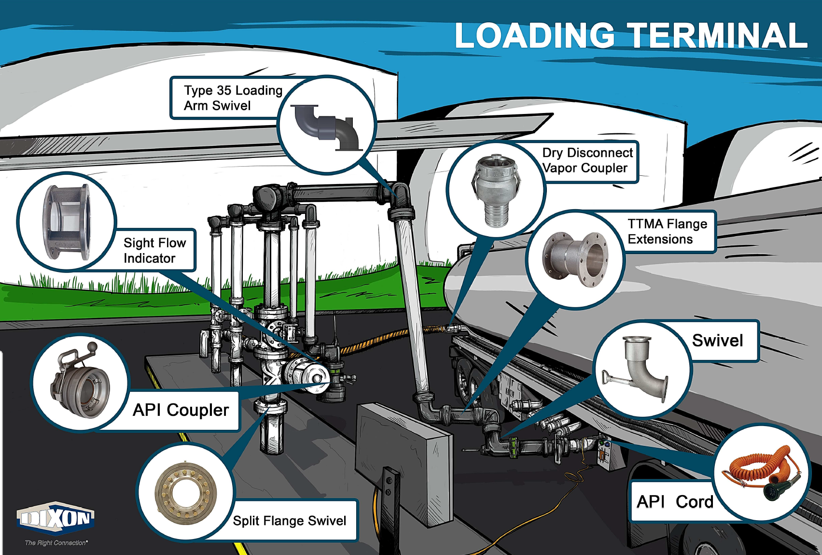

Loading Arms
A loading arm is a dynamic system allowing for the transfer of media such as liquids, liquified gas, or dry bulk from one storage vessel to another. Consisting of a combination of swivel joints, pipe and/or hose legs, a counterbalance, and various end connections, loading arms can be configured for both top loading and bottom loading applications. Dixon® loading arms are ideal for a wide range of applications, transferring product to and from tank trucks or rail cars as well as to drums and totes.
Sizes
- 3" and 4"
Features
- Torsion spring counterbalance offered in left or right hand
- Base swivels offered: carbon steel V-ring, carbon steel split flange, or 316 stainless steel split flange
- Style 50 loading swivel
- Available accessories include safety breakaway, Wet-R-Dri™ valve, ball handle (see pages 20-29)
Materials
- Pipe leg materials offered: aluminum, carbon steel, and 316 stainless steel
- Available seals include: nitrile rubber, FKM, low temperature FKM, PTFE, EPDM, and food-grade nitrile
Specifications
- Standard configurations below include carbon steel base swivels, ESB1 torsion spring counterbalance, TTMA extension, 5500-series API, and D-handle
- Other options available upon request

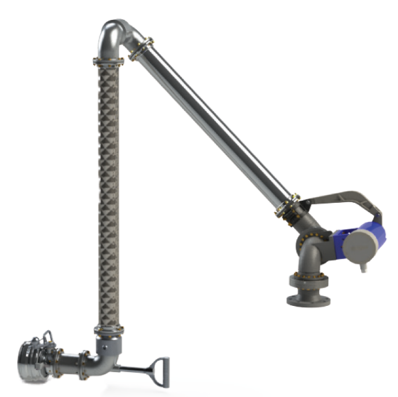

Scissor Style Loading Arm
Sizes
- 2", 3”, and 4”

Features
- Torsion spring counterbalance offered in left or right hand
- Base swivels offered: carbon steel V-ring, carbon steel split flange, or 316 stainless steel split flange
- Available accessories include tee deflector, diffuser, top loading valve with or without remote handle kit, various handles, locking mechanism (see pages 20-29)

Materials
- Pipe leg materials offered: aluminum, carbon steel, 316 stainless steel
- Available swivel seals include: nitrile rubber, FKM, low temperature FKM, PTFE, EPDM, or food-grade nitrile

Specifications
- Standard configurations below include carbon steel split flange base swivel, aluminum legs, top load valve, remote handle kit, and FKM seals
- Other options available upon request

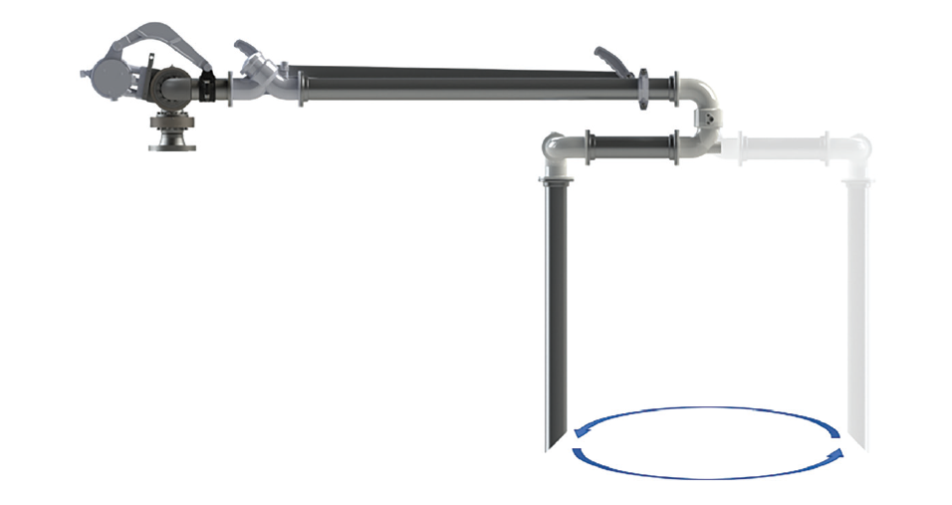

Overfill Protection Rack Monitors
Application
• Installed on the gantry to control the loading process of
petroleum fuels or other hazardous liquid into cargo tanks
Features
• Automatically switches between 2-wire or 5-wire
type sensors
• Compatible with analog 2-wire thermistor type sensors
• Redundant relay outputs prevent single point failures
• Data management via RS485 port
• Wireless bypass key system
• Ground verification
• Reads trailer identification modules
Approvals
• Meets API RP1004 and EN13922 standards
• Suitable for Class I, Division 1, Group CD and Class I,
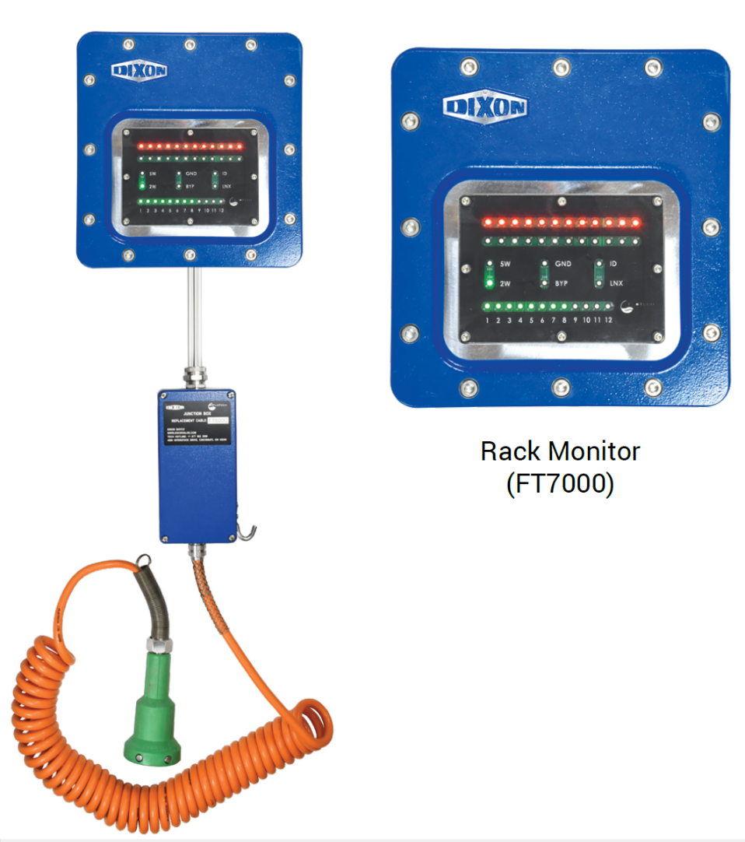
Zone 1, and Group IIB

